**1. Create a test**

1.1 We create *Test Plan -> Add -> Threads ->Thread Group*

* 1. Rename it to “SoftWareTest” and set the required number of users there.
  2. Add to view the results of the Summary Report
  3. Add to SoftWareTest -> *Add -> Logic Controller -> Recording Controller*

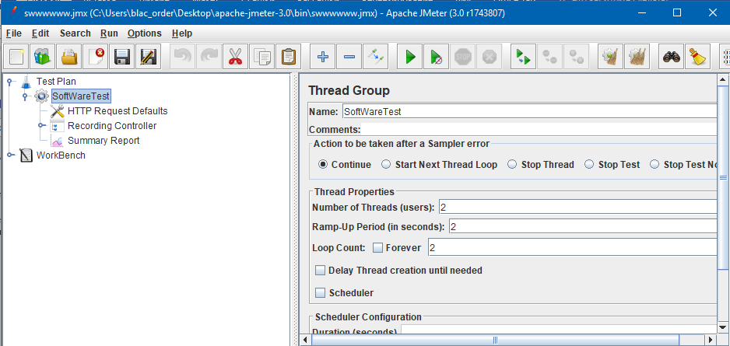

Picture 1

1.5. Add to WorkBench -> Add *-> Non-Test Elements* -> *HTTP(S) Test Script Recorder*

Add to WorkBench -> Add *->**HTTP(S) Test Script Recorder*

Add to *HTTP(S) Test Script Recorder* -> Add *->**View Results Tree*

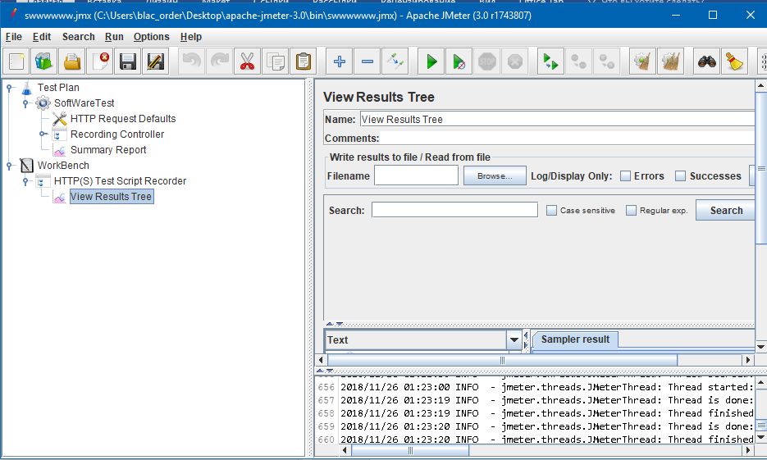

Picture 1.2

**2.Configuring your browser to use the JMeter proxy server**

2.1 Start Firefox without closing *JMeter.*

2.2 On the toolbar, click Open Menu -> Settings

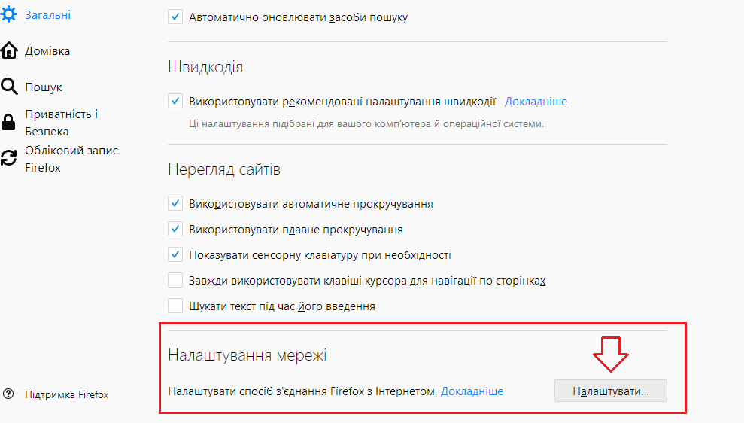

Picture 2

*2.*3 Go to the “*Settings*” tab

In a new pop-up window, check the *proxy server configuration* manually. The address and port fields should now be enabled. (Temporary) *Address* enter localhost or your system's IP address Port enter *8181* **.**

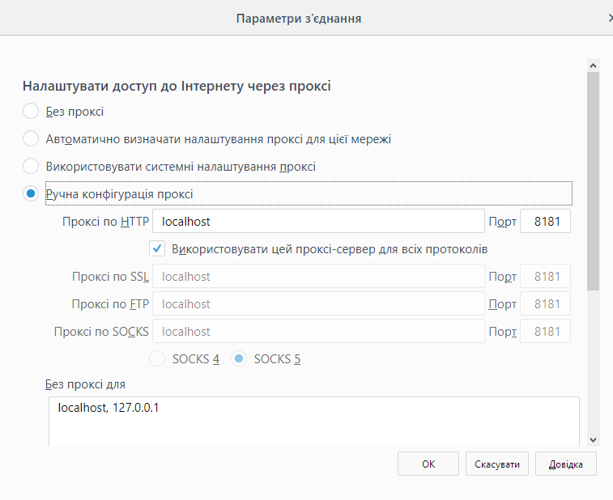

Picture 2.1

3.Run test

3.1 Go to the HTTP(S) Test Script Recorder tab

3.2 Click on the *Start button*

3.3 Next, *in the browser, perform the* necessary actions with the site

3.4 After you *need to stop* HTTP(S) Test *Script Recorder*

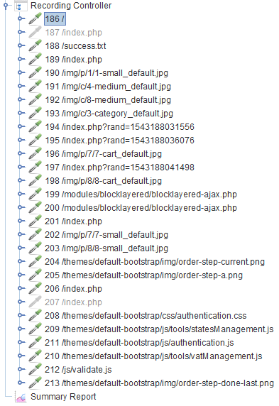

Picture 2.2

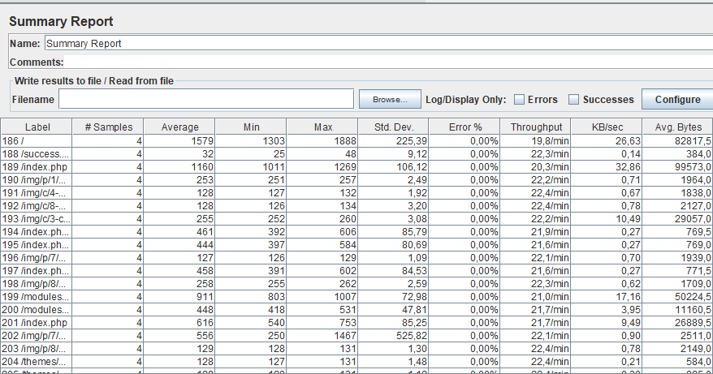

Picture 3

4. Editing the data (Fig. 4)

4.1 In the fields enter

4.2 *Number of users* - 60

4.3 *Delay period* - 2

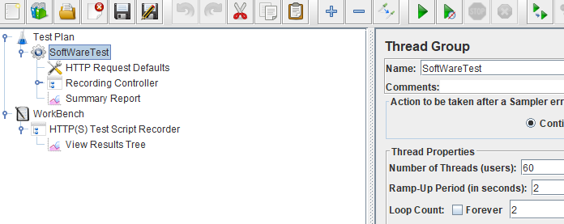

Picture 4

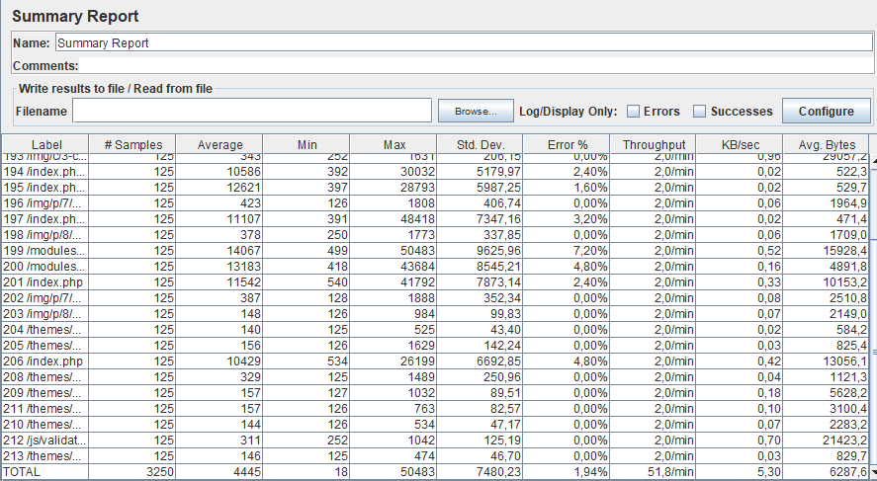

Picture 4.2